[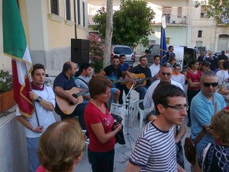](http://www.francolofrano.it/wp-content/uploads/2012/06/tn_Foto2064.jpg)